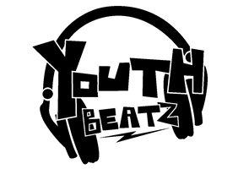

Showcase your local organisation at this year’s Youth Beatz Festival 2026, by applying for a stall in the
‘Youth Information Marketplace’

General Information
Youth Beatz is Scotland’s largest music festival, taking place each year in Dumfries. The 2-day event that sees an audience of 20,000 attending per day. This year’s event is being held on Saturday, 27th June and Sunday, 28th June 2026 at Park Farm Show field in Dumfries, DG2 7LU.

Youth Beatz is a festival designed by young people in partnership with Dumfries and Galloway Council’s Youth Work Service and delivered for the whole community. There is more to Youth Beatz than our mainstage acts with a wide range of daytime activities, community spaces, our interactive drama production The Toon, dedicated Youth Work area and Youth Information Marketplace providing something different for attendees, beyond the music.

To learn more about Youth Beatz please visit www.youthbeatz.co.uk

What we can offer:
We have a dedicated Youth Information Marketplace for organisations who work with young people in Dumfries and Galloway. This is an exciting opportunity to showcase your work and promote services to 40,000 people over the festival weekend with over 30,000 of attendees coming from across Dumfries and Galloway.

This year, our marketplace will feature organisations housed together under one Marquee tent.

These spaces are open for you to use as you require and we would encourage participating organisations to be creative, (think outside the box) and develop innovative ways to engage with festival go-ers, especially young people. We suggest incorporating more interactive activities alongside traditional printed materials to create a more dynamic and engaging experience for all.

What’s involved:
Any organisation who is interested is encouraged to apply for a space within the Youth Information Marketplace.

There are conditions organisations agree to at the point of application:

- Stalls will be provided at no cost to the organisation for both days, however if you do not show up or cancel, a charge of £50 per stall will apply. We incur costs to provide the stalls and in recent years we have had organisations not show up and we have still incurred the costs.
- By completing and submitting this form you acknowledge and confirm your agreement that you will be charged £50 if you do not show up or cancel the stall with less than 3 days notice.
- Stalls must be ‘live’ with your organisations staff or volunteers in attendance between 12noon – 6pm on both Saturday 27th June and Sunday 28th June (we cannot accept applications for a single day). Stalls must be set-up for 11:15am each day of the festival to ensure safety inspections can be carried out.
- Vehicle access is limited on the event days, no vehicles will be able to access the site on the event days to remove equipment. There will be scheduled timeslots for organisations to bring/remove equipment by vehicle on Friday 26th June and Monday 29th June (where applicable).
- All equipment can be safely stored in the marquee overnight on Friday until Monday.
- Strictly no selling/collection of donations are allowed, this opportunity is to showcase your services to young people. Stalls are only available to non-profit groups (no commercial businesses).
- Stalls must only offer what is specified in their application. Any changes to the application form must be made in writing.
- Sub-Contracting: Stalls and spaces or parts of stalls or spaces by organisations is not permitted.
- The Management reserve the right to reallocate stalls if essential for operational reasons or if stallholders arrive late.
- Amplified music: No music to be played.
- Strictly no food or drink to be distributed (as a sale or free).
- Organisations must be aware of the needs of people with disabilities, activities must be accessible for all.
- All organisations are required to commit to both days of the event. Requests for single-day attendance will not be considered.

Following your application, you will be asked to return a more detailed terms and conditions document that all contractors and stall holders must agree to.

Applying for a Stall:
If you are interested in applying for a stall for your organisation at Youth Beatz 2026, please complete your online application using the link below or scanning the QR code no later than Friday 24th April 2026.

The application will not let you progress unless you have uploaded your risk assessment for the stall and a copy of your insurance document.

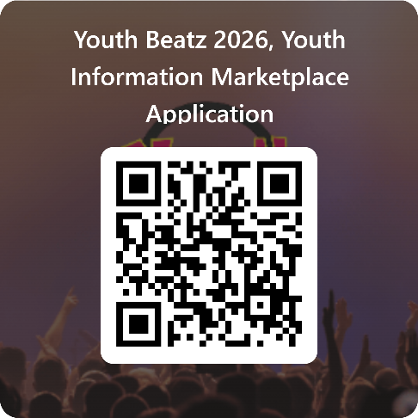

Youth Beatz 2026, Youth Information Marketplace Application – Fill in form

Parking:
Please note that there is limited organisation parking close to the site. This will be strictly limited to one vehicle per organisation and will only be accessible with the correct vehicle pass.

Food:
Catering will be available at our food village throughout the day should you wish to purchase food or drinks.

Health & Safety:
- Organisations must comply with the Health, Safety and Hygiene requirement of Dumfries and Galloway Council.
- On Friday 26th and Monday 29th June you must wear a hivis vest to get access to marketplace, you may not be allowed to enter the site if you do not have one.
- Organisations are not permitted to start trading until they have been given the go ahead by the Health and Safety Officer, following a Health and Safety Inspection.
- Official organisation: Organisations are required to co-operate fully with Event and Site Management, The Event Safety Officer and Security.
- Promotional give-aways: strictly no items that can be used as missiles allowed on site. Please detail any items you would like to distribute at the event in your application.
- Waste: stall holders are responsible for keeping both the 5-meter area both at the front and back of their space tidy and free of rubbish. Stall holders must leave their site as they found it. All rubbish must be put into the appropriate bins.
- We ask you all to please take care of the environment.

We reserve the right to decline any stall applications. This is a final decision from the event organiser and you will be informed after the closing date if this is the case. Reasons may include; commercial trading, space restrictions, your organisation is not a not for profit organisation or is not solely targeted at young people.

